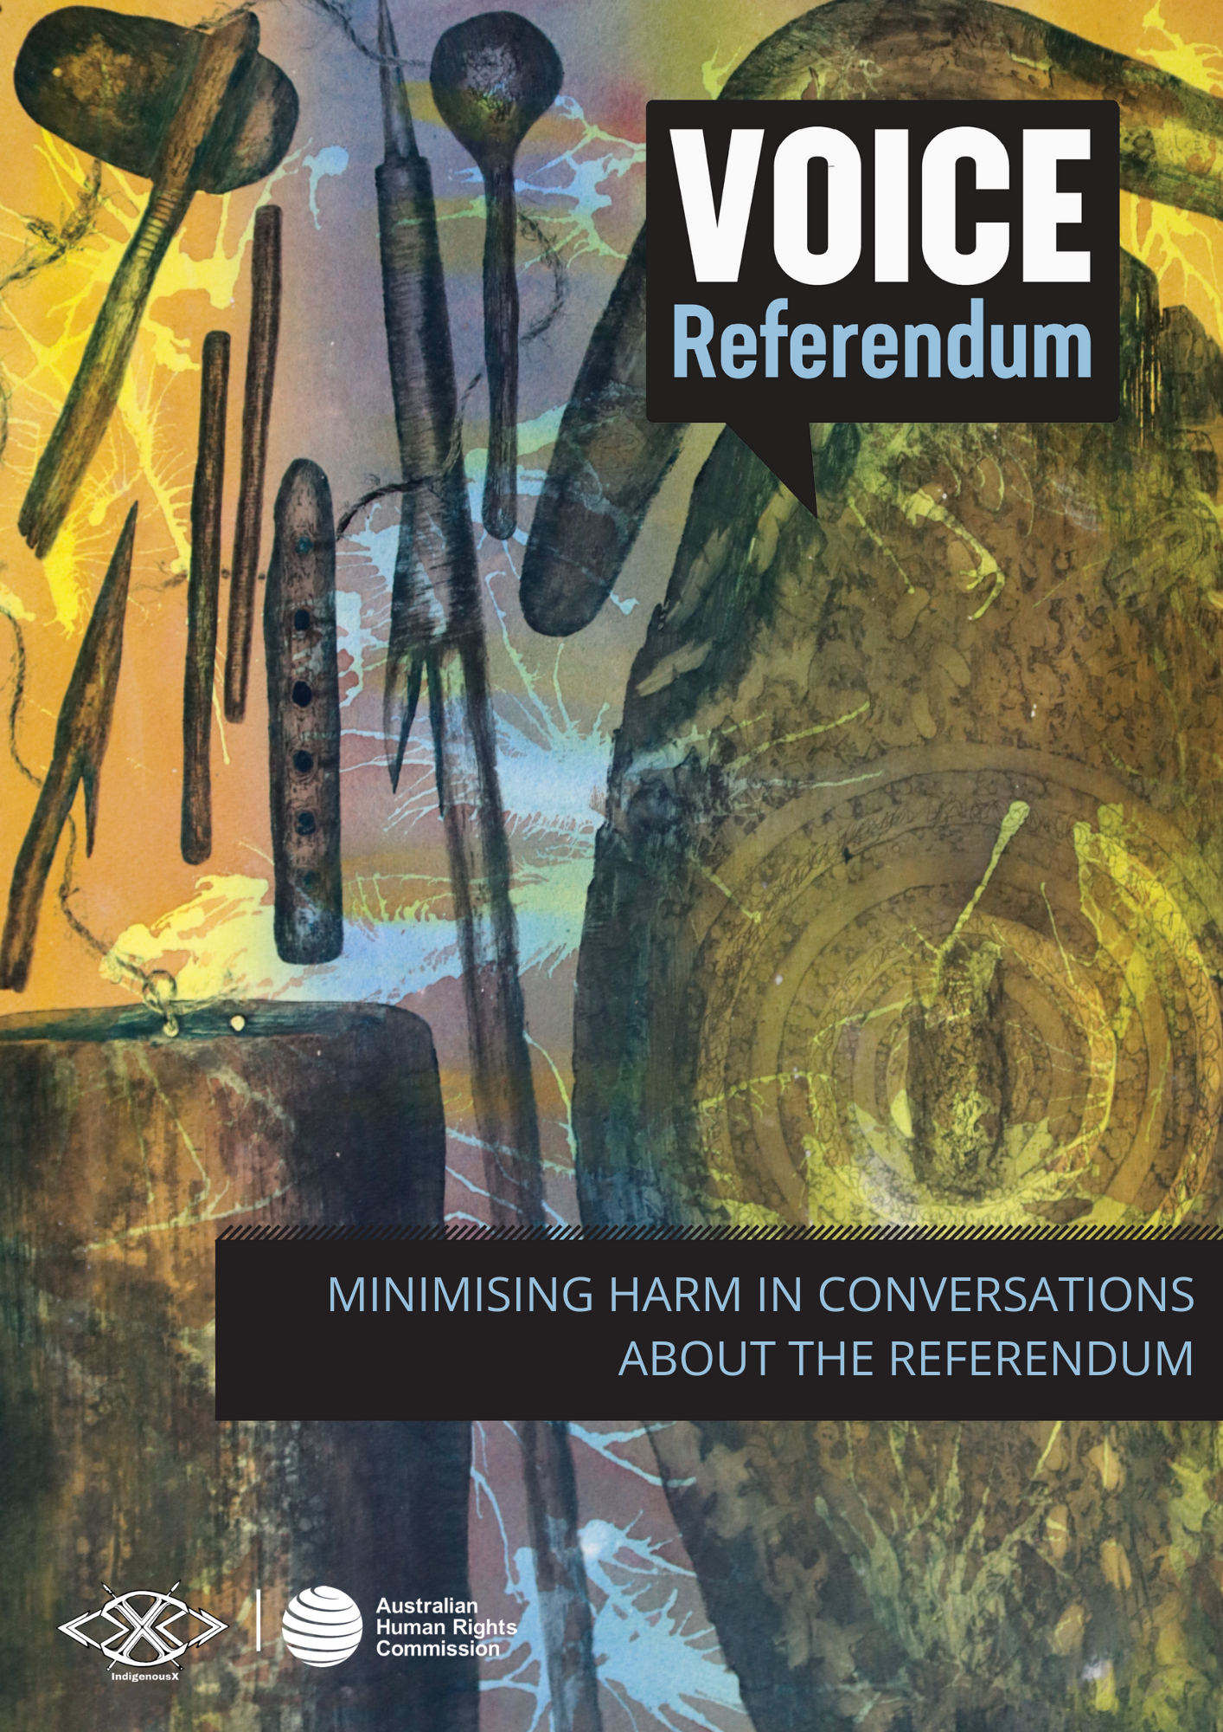

MINIMISING HARM IN CONVERSATIONS ABOUT THE REFERENDUM

Too often, Indigenous peoples are the subject of national debates that cause direct and indirect harm.
In a democracy, it’s important that people can express their opinions on key issues, especially those of great national importance. However, it is crucial that these conversations are approached in a way that is factual, is not based on racial stereotypes, does not involve racially denigrating language, and does not cause harm to Indigenous peoples. This is particularly important when discussing issues that disproportionately affect certain individuals and communities, such as the referendum for an Indigenous Voice to Parliament.
This section of the document provides information and practical tips to engage in conversations about the referendum in ways that minimise harm, including:
- Practise cultural humility
- Centre Indigenous knowledges, voices, and perspectives
- Remember, there is no one true ‘Indigenous perspective’
- Avoid deficit discourse
- Call out and actively combat fear tactics

Practise cultural humility
Acknowledging the potential for harm and working to minimise it, while still being able to express personal views and opinions takes a certain level of thoughtfulness, respect and cultural humility.
Cultural humility is a lifelong process that requires each of us to examine our own views about race and racism, and how racism has influenced our experiences, our opportunities, and our relationships. Aunty Dulcie Flower OAM, an Elder of the Erub nation and the first Torres Strait Islander nurse involved in the formation of the Redfern Aboriginal Medical Service, describes cultural humility as “something that you learn; you’re not born with this, it’s a whole learning process”.
Cultural humility necessitates a willingness for self-evaluation, learning, and self-reflection. It is a commitment to fix power imbalances that occur within social interactions, institutions and society itself. It requires a transparent commitment to institutional accountability for often systemically racist and harmful policies and practices, as part of developing and maintaining reciprocal relationships with Indigenous peoples based on trust and respect.
Within a framework of cultural humility, the goal is not to become an ‘expert’ on Indigenous people and cultures, but instead it is about having a respectful and realistic framework. Such a framework seeks to understand, while not expecting all Indigenous people to be teachers or to fit into any preconceptions of what Indigenous people should think or do.
Commit to practising cultural humility.
Talk to your organisation about cultural safety and cultural humility training. Some Indigenous organisations offering this service include: Jumbunna Institute for Indigenous Education and Research, IndigenousX, Indigenous Psychological Services (IPS), Centre for Cultural Competence Australia, and Aboriginal Insights.
Watch an animated video that introduces the concepts of cultural safety, humility, and awareness, produced by the Indigenous Health Team of Northern Health, Canada.

Centre Indigenous knowledges, voices and perspectives
Indigenous peoples have long been excluded from decision making. Often, Indigenous peoples are treated as an object of debate – a problem to be solved by non-Indigenous people who believe they know what is best for Indigenous people. This is dehumanising.
It can play out whenever Indigenous topics are being discussed by non-Indigenous people in the media, politics, online, in workplaces or in schools, without any Indigenous representation and perspectives.
Indigenous peoples have rights to representation and participation in matters that affect them, as well as rights to be consulted and have their voices heard. Learn more about this in the ‘Indigenous rights and the Voice’ section of the Voice referendum resource suite.
When witnessing or engaging in discussions about Indigenous people, issues and communities, consider the extent to which Indigenous knowledge, voices and perspectives are centred.
It’s appropriate and important to seek a range of perspectives from First Nations peoples and to reflect and draw on these in a way that is fair, appropriate and accurately portrays the intent of the original speaker or author.
Organising a community or workplace event? Ensure that First Nations people and perspectives are considered, consulted and included.
For media made by, for and about Aboriginal and Torres Strait Islander people, check out organisations like: National Indigenous Television (NITV), National Indigenous Radio Service (NIRS), Koori Mail, and IndigenousX.

Remember, there is no one true ‘Indigenous perspective’
The desire to have Indigenous individuals speak on behalf of all Indigenous people stems from the commonly held misconception that Indigenous people are a homogenous group with the same views on social, political and cultural issues. This can lead some non-Indigenous people to become confused or angry when confronted with a diversity of opinion amongst Indigenous peoples.
There are over 250 unique Indigenous nations and hundreds of thousands of individuals, with a wide range of views. Some non-Indigenous people struggle with this, leading them to label views outside of the one they deem to be ‘authentic’ as ‘less Indigenous’. When used by non-Indigenous people, terms like ‘sell out’, ‘fake’, ‘urban’, ‘elite’ and other words designed to belittle the identity and perspective of Indigenous people are harmful and unhelpful.
It’s unrealistic to expect consensus amongst Indigenous people, just as it would be to expect this from any other group in Australia.
Listen to a range of Indigenous voices and consider which ideas resonate. That is the natural and inevitable outcome of respectfully listening to a diverse range of views on any topic.
It’s ok to disagree, to fact check, and to have strongly held beliefs. But showing cultural humility means understanding that the desire for a single ‘authentic’ Indigenous voice is unreasonable and unrealistic, and every single Indigenous person is entitled to their beliefs and views, just as every other Australian is. Every human being is deserving of dignity and respect.

Avoid deficit discourse
Deficit discourse is when we talk about Indigenous people and issues as though there is an innate deficit or deviance with being Aboriginal and/or Torres Strait Islander.
“'Deficit discourse' refers to disempowering patterns of thought, language and practice that represent people in terms of deficiencies and failures.” – Lowitja Institute Summary Report.
It commonly attempts to blame Indigenous people for challenges and circumstances, often ignoring the larger social, economic, political and historical factors which are major contributors.
Taking a strengths-based approach is necessary to combatting deficit discourse. This approach seeks ‘to move away from the traditional problem-based paradigm and offer a different language for thinking about and discussing issues’. It involves emphasising strengths, culture, country, rights and partnership, in the context of First Nations people.
Refuting deficit discourse means challenging racial stereotypes and ensuring that conversations about Indigenous people and issues are conducted in a way that upholds the respect and dignity of individuals, communities and cultures.

For more information on deficit discourse, see this Summary Report from the Lowitja Institute.

Call out and actively combat fear tactics
From the earliest days of colonisation, fear campaigns attempting to paint Indigenous people as an innate risk have been common.
From fears about Indigenous people stealing cattle to wanting ‘free handouts’, these messages evoke harmful racist stereotypes that pose a threat to the health and safety of Indigenous people. They have the potential to affect Aboriginal and Torres Strait Islander people’s experiences, limit life opportunities, and influence funding and policy decisions from governments and other organisations.
Reactions like ‘Aboriginal people are going to steal your backyard’ in the wake of the Mabo decision, is an example of a fear tactic. This method, used historically and in contemporary debates, generates fear and animosity towards Indigenous people. This is then used to undermine Indigenous rights and justify taking systemically racist and harmful approaches, policies and practices to Indigenous affairs, that would otherwise be considered unacceptable.
In conversations about the referendum, take a stand against divisive and racist discourse. Call out harmful fear tactics when observed, and work to minimise harm.
Keen to learn more about practical conversations and messaging that works? Passing the Message Stick is a multi-year, First Nations research project that lays out the messaging needed to build public support for self-determination and justice, paving the way for long term change.

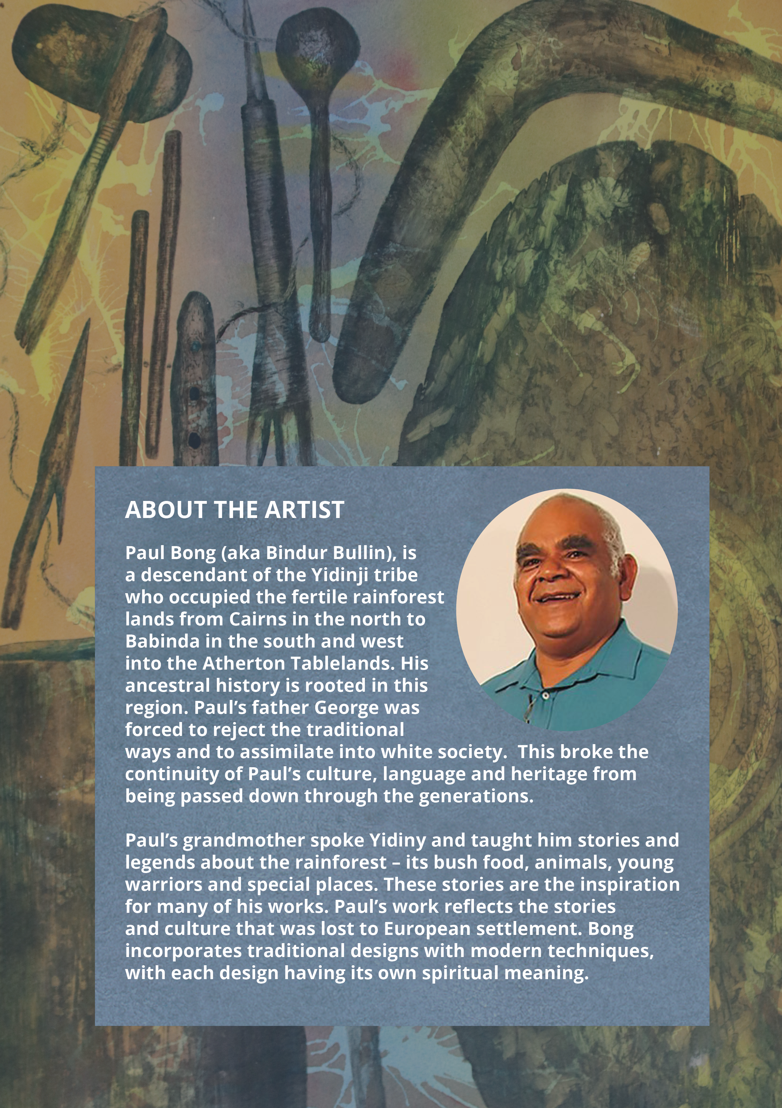

Aunty Dulcie Flower OAM, ‘A pathway to wellbeing through Cultural Safety and Cultural Humility’, Croakey Health Media (Web Page, 2022).
The Lowitja Institute, ‘Deficit Discourse and Aboriginal and Torres Strait Islander Health Policy Summary Report’, (May 2018) 3.
Robert Gottliebsen, ‘Backyard native title is no joke’ The Australian Financial Review (5 May 1997).

